437M
JERZEES

Jersey Knit Sport Shirt

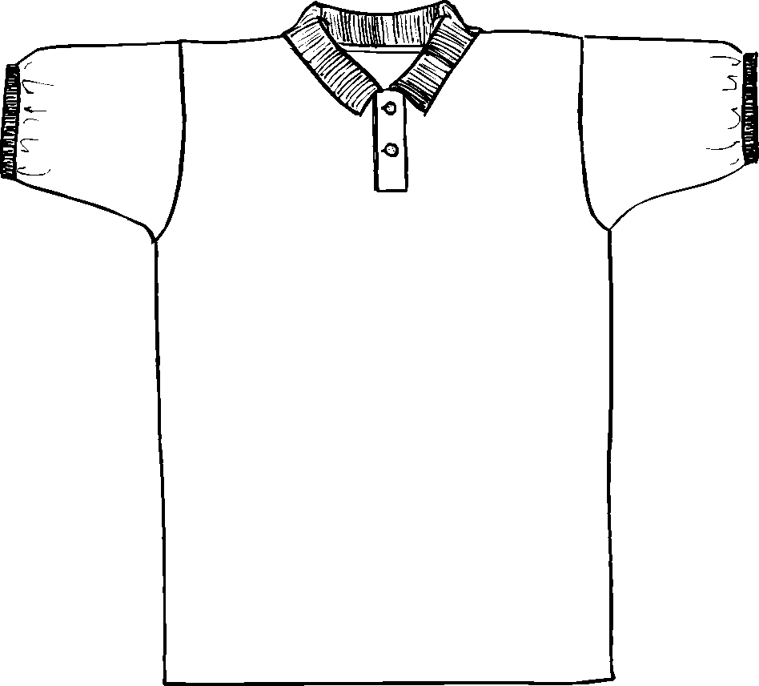

Descriptions
*50/50 poly cotton, 5.6 ounces
*Welt collar
*Rib knit cuffs
*Pearlized 2 button placket
*Double needle bottom hem
*Embroidery & screenprinting okay

Finished Garment Measurements

Size | S | M | L | XL | 2XL | 3XL | 4XL
Width 1” under armhole | 19 | 21 | 23 | 25 | 27 | 29 | 30
Length from shoulder point | 29 | 30 | 31 | 32 | 33 | 34 | 35
Shoulder Width | 17 | 19 | 20 ½ | 22 | 23 ½ | 25 | 26 ½
Sleeve Length from CB | 19 ½ | 20 ½ | 21 ½ | 22 ½ | 23 ½ | 24 ½ | 25 ½

